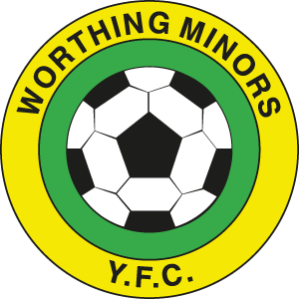
WORTHING MINORS
COVID-19 MATCHDAY GUIDELINES

- Players should arrive ready to play.
- All spectators should observe government social distancing guidelines, with opposing team spectators stood on opposite sides of the pitch with their manager, where possible.
- Pre-match handshake should not take place. Instead players will be asked to hand-sanitise before kick-off.
- Team talk huddles should not take place. Team talks can take place, as long as social distancing is observed.
- Warm-ups/cool-downs should always observe social distancing.
- On touchlines/dug-outs, Social-distancing must also be observed during interactions when a substitution is being made.
- Set plays – free kicks: referees and coaches should encourage players to get on with the game and not unnecessarily prolong set play set-up, such as defensive walls.
- Set plays – free kicks and corners should be taken promptly to limit prolonged close marking and goal posts should be wiped down before matches, at half time and after the match.
- Goal celebrations should be avoided.
- Interactions with referees and match assistants should only happen with players observing social distancing.
- Breaks, Half time & Full time. Hand hygiene should be carried out.
- No spitting.
- Coughing/Sneezing should be aimed away from others, preferably into elbow crease.
- When the ball goes out of play it should not be retrieved by non-participants and should be retrieved using the feet rather than the hands where possible.
- If a participant gets injured, a member of their household can assist if present and appropriate, but others (including match officials and teammates and coaches) will still need to socially distance unless a life- or limb-threatening injury necessitates compromising guidelines to provide emergency care.
- If a participant becomes Covid-19 symptomatic before or during the match, they should immediately remove themselves from the venue and return home as soon as possible.

