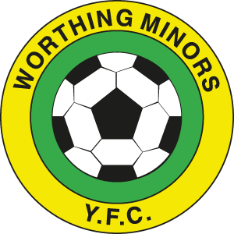

Code of Conduct for Parents

\Worthing Minors expect all parents / spectators within our club are always positive and encouraging towards all of the children not just their own.
Parents / spectators should:
1. Applaud the opposition as well as you own team.
2. Avoid coaching the child during the game.
3. Not to shout and scream.
4.Respect the referee’s decision.
5.Give attention to each of the children involved in football not just the most talented.
6.Give encouragement to everyone to participate in football.
7.Parents / Spectators within our club agree and adhere to your club’s Code of Conduct and Child Protection Policy.

